EWIPA – Press Pack – Photos
All photos: © MAG/Sean Sutton
Photo | Context/ year | Caption
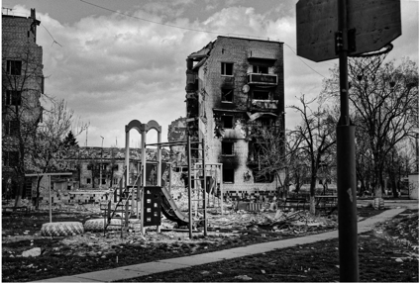 | Ukraine  2022 | Large areas of Bodoryanka were destroyed during intense and sustained bombardments.  https://www.flickr.com/photos/8301862@N05/52278646206/in/album-72177720301218156/
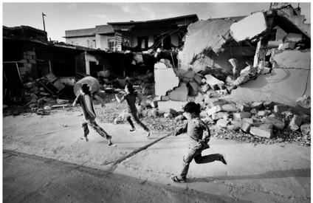 | Iraq 2015 | Children run past destroyed buildings in Zommar, Iraq.  https://www.flickr.com/photos/8301862@N05/52278646111/in/album-72177720301218156/
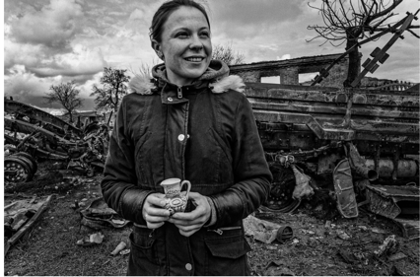 | Ukraine 2022 | Raisa fled with her husband, son and dog when their village was bombed. This vase is the only thing that survived from her home.  https://www.flickr.com/photos/8301862@N05/52046577742/in/album-72177720298602836/
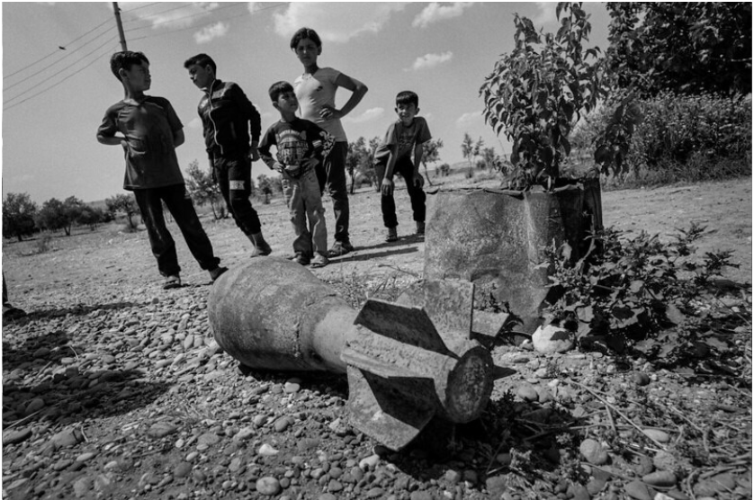 | Syria 2019 | Children play near an unexploded ISIS Mortar bomb.  https://www.flickr.com/photos/8301862@N05/52278913444/in/album-72177720301218156/
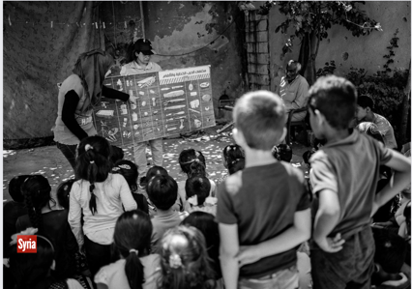 | Syria 2017 | Children receive vital life-saving lessons in Al Raqqa.  https://www.flickr.com/photos/8301862@N05/52277667547/in/album-72177720301218156/
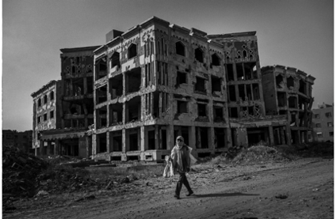 | Syria 2019 | Raqqa City was destroyed in the war. Even when a conflict ceases, people are not safe whilst deadly explosives still litter their neighbourhood.  https://www.flickr.com/photos/8301862@N05/52278914229/in/album-72177720301218156/

